Support with Parenting: Pre-school and School age, including SEND
Help with parenting: ages 2 years - 10 years
Workshops and support groups If you would like to find out more about these groups, or to book onto our next available workshop please contact your local Family Hub on 01905 520 032.
Understanding Your Child (includes Emotional wellbeing and dealing with challenging behaviour  Access code PARENTSROCK | Understanding your child with additional needs  (includes Emotional wellbeing for parents and children, and communicating effectively.)  Access code PARENTSROCK | Dealing with Challenging Behaviour  This charity is devoted to helping parents understand and deal with challenging behaviour from their children.

Strengthening Families Parenting Course (Age 0-7, 7-11, 11-18)

Special Educational Needs and Disabilities (SEND)
SEND Local Offer  The SEND local offer gives the councils services for helping children and families with a special educational need and/or a disability. | SENDIASS (Advice & Support)  SENDIASS supports parents, carers, children and young people with SEND and our service is impartial and confidential. Our office opening hours are Monday to Friday from 8.30am to 4.00pm. 01905 768153. | - Support Groups  A comprehensive list of support group in Worcestershire.
- Blindness & Partial Sightedness
Sight Concern  Sight Concern is our local charity which provides advice, support and groups for families living with partial sight or blindness. | National Blindness and Sight Impairment Charities  RSBC Royal Society for Blind Children  Royal national Institute for Blind People | Guide Dogs  Guidance around helping blind children at home and the role of guide dogs in their lives.
Deafness and Hearing Impairment
Hearing Impairment Service  Help and information for the parents of children living with a hearing impairment.  Hearing Impairment Service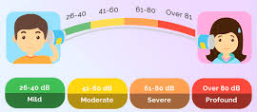 | Hearing Impairment Support  National Deaf Children’s Society  Royal National Institute for the Deaf  Deaf awareness tips (PDF) | British Sign Language Resources  Learn British Sign Language  British Sign webpage  100 basic signs in BSL (YouTube)  BSL interpretation services in Worcestershire (PDF)
Autism Spectrum Condition
Ambitious About Autism  A really friendly and comprehensive website for all kinds of support for families living with autism, with a vibrant Facebook page. | Arum Autistic Support  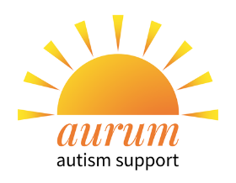  Specialist support for Autistic women and girls. | National Autistic Society  This national charity also has a Worcester Branch Facebook Page. They raise funds and awareness for people living with Autism and Asperger’s.
Pets and Safety
RSPCA - Keeping children safe around dogs | Nursing Times: Advice for keeping babies safe around dogs in the home | The Dogs Trust – Preparing your dog for a new baby in the home.

