Malvern Wyche C of E Primary School




Special educational needs and Disability (SEND) information report

Approved by | Full Governing Board |   Signed
Date | 30th September 2026 | Caroline Talcott

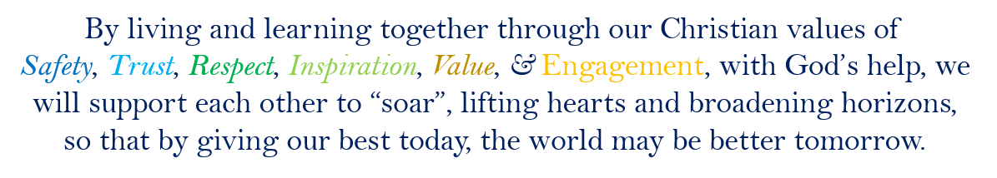

Contents
Contents 3
1. What types of SEN does the school provide for? 4
2. Which staff will support my child, and what training have they had? 4
3. How will the school know if my child needs SEN support? 6
4. What should I do if I thiunk my child needs Sen support? 6
5. How will the school measure my child’s progress? 7
6. How will I be involved in decisions made about my child’s education? 7
7. How will my child be involved in decisions made about their education? 8
8. How will the school adapt its teaching for my child? 8
9. How will the school evaluate whether the support in place is helping my child? 9
10. How will the school resources be secured for my child? 10
11. How will the school make sure my child is included in activities alongside pupils who don’t have SEN? 10
12. How does the school make sure the admissions process is fair for pupils with SEN or a disability? 10
13. How does the school support pupils with disabilities? 11
14. How will the school support my child’s mental health and emotional and social development? 11
15. What support will be available for my child as they transition between classes or settings or in preparing for adulthood? 11
16. What support is in place for looked-after and previously looked-after children with SEN? 12
17. What should I do if I have a complaint about my child’s SEN support? 12
18. What support is available for me and my family? 13
19. Glossary 13

Preamble
At Malvern Wyche C of E Primary School we are an inclusive mainstream setting. Staff work hard to provide additional and, where required, tailored, provision for the needs of our pupils. The aim of this information report is to explain how we implement our SEND policy. In other words, we want to show you how special educational needs support works in our school.

1. What types of SEN does the school provide for?

Area of need | Condition
Communication and interaction | Autism spectrum disorder (ASD)
Communication and interaction | Speech and language difficulties
Cognition and learning | Specific learning difficulties, including dyslexia, dyspraxia, dyscalculia
Cognition and learning | Moderate learning difficulties
Cognition and learning | Severe learning difficulties
Cognition and learning | Profound and Multiple Learning Difficulties (PMLD): Physical Disability (PD)
Social, emotional and mental health | Mental Health and Well Being
Social, emotional and mental health | Social Need
Social, emotional and mental health | Emotional Need
Social, emotional and mental health | Autism spectrum disorder (ASD)
Social, emotional and mental health | Attention deficit hyperactivity disorder (ADHD)
Social, emotional and mental health | Attention deficit disorder (ADD)
Sensory and/or physical | Hearing impairments
Sensory and/or physical | Visual impairment
Sensory and/or physical | Multi-sensory impairment
Sensory and/or physical | Physical Disability (PD)

2. Which staff will support my child, and what training have they had?
2.1 Our special educational needs co-ordinator, or SENCO
Our SENCO is Vicky Whitehurst, her contact details are office@wyche.worcs.sch.uk. She has been SENDCO since 2020. And she is a qualified teacher of 27 years. She achieved the National Award in Special Educational Needs Co-ordination in 2021. Mrs Whitehurst completed Trauma informed training in 2022 and was Thrive trained in 2014. The SENDCO is allocated 1 day a week to manage SEN provision.
2.2 Our Governor responsible for SEND is Julia Husband.
The governing body can be contacted through the governance professional who acts as clerk to the board: clairefinchgovernance@gmail.com.
2.3 Class/subject teachers
All of our teachers receive regular in-house SEN training, and are supported by the SENCO to meet the needs of pupils who have SEN. We regularly consult with professionals, such as Educational Psychology and Complex Communication team where needed so that teachers have the most effective and up to date advice. Teachers write and follow individual Education Plans (IEPs) and work towards the targets of EHCPs where they are provided.
2.4 Teaching assistants (TAs)
We have a team of 11 TAs, six of whom work 1:1 supporting pupils with an education heath care plan (EHCP). All TAs are trained to support pupils with SEND and deliver tailored interventions under the direction of the class teacher, monitored by the SENCO.
2.5 External agencies and experts
Sometimes we need extra help to offer our pupils the support they need. Whenever necessary we will work with external support services to meet the needs of our pupils with SEN and to support their families. These include:
- Speech and language therapists
- Educational psychologists
- Occupational therapists
- GPs or paediatricians
- School nurses
- Child and adolescent mental health services (CAMHS)
- Education welfare officers
- Social services and other local authority (LA)-provided support services
- Voluntary sector organisations

3. How will the school know if my child needs SEN support?
3.1 We assess each child’s knowledge, skills and levels of attainment when they start school, beginning with the home visit. This can be when they start reception or when children join us from other schools in-year, which can be after their reception year. Each class teacher also makes regular assessments of attainment and progress for all children throughout the year.
3.2 All staff receive regular training and updates in SEND and are aware of the need to be vigilant for signs of that the children in their care are experiencing barriers to their learning which may come under the SEND umbrella. Initially they look out for any pupils who aren’t making the expected level of progress in their schoolwork.
3.3 If the teacher notices that a pupil is falling behind, they try to establish where there may be gaps in learning. If a gap is identified, pupils will receive extra support after having identified strategies from one or more of the four areas of need (Communication & Interaction, Social, Emotional & Mental Health, Cognition & Learning & Sensory and/or physical. Targeted interventions will be put in place and parents will be informed.
3.4If the pupil is still struggling to make the expected progress despite having received a short, focussed intervention, the teacher will talk to the SENCO, parents will be contacted to explore the possibility that the child may have some barriers to learning which we could describe as special educational needs or disability. Where two attempts to put strategies in place do not appear to be helping the child to make progress, we will contact parents to discuss putting in place formal SEND provision. We call this "two cycles of plan, do, review" meaning we will make a plan, carry it out, evaluate it and communicatee the results.
3.5 Where appropriate the SENCO will observe the pupil in the classroom and in the playground to see what their strengths and difficulties are. They will have discussions with your child’s teacher(s), and any other relevant adult(s), to see if there have been any issues with, or changes in, their progress, attainment or behaviour. They will also compare your child's progress and development with their peers and available national data.
3.6 The SENCO will ask for your opinion and speak to your child to get their input as well. They may also, where appropriate, ask for the opinion of external experts such as, but not limited to, a speech and language therapist, an educational psychologist, or a paediatrician.
3.7 Based on all of this information, the SENCO will decide whether your child needs SEN support. You will be told the outcome of the decision in writing giving an idea of what to expect..
If your child does need SEN support, their name will be added to the school’s SEND register, and staff will work with you to create an IEP or SEN support plan for them.

4 What should I do if I think my child has SEN?
If you think your child might have SEND, the first person you should tell is your child’s teacher.  The best way to get in touch with your child's teacher is by sending an email to office@wyche.worcs.sch.uk outlining your concerns.  If appropriate they will pass the message on to our SENCO, Vicky Whitehurst who will be in touch to discuss your concerns.  You can also contact the SENCO directly via office@wyche.worcs.sch.uk, addressed FAO Mrs Whitehurst | We will meet with you to discuss your concerns and try to get a better understanding of what your child’s strengths and difficulties are.  Together we will decide what outcomes to seek for your child and agree on next steps.  We will make a note of what’s been discussed and add this to your child’s record. You will also be given a copy of this. | If we decide that your child needs SEND support, we will formally notify you in writing and your child will be added to the school’s SEND register.

5. How will the school measure my child’s progress?
5.1 When a child has been identified as having a special educational need, the graduated approach is used as stated above. This is a cyclical process:

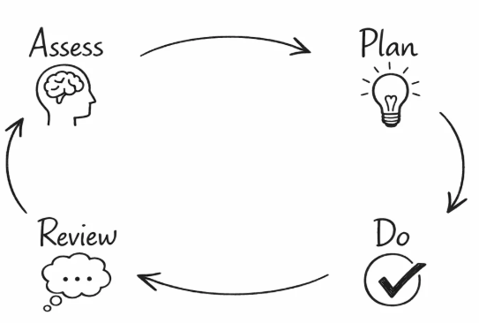

- Assess: establishing a starting point in a specific area
- Plan: planning appropriate steps to bridge the gap
- Do: the implementation of an intervention and strategies to support the child
- Review: finally completing a review of the intervention to see how effective it has been

5.2 Whenever we run an intervention with your child, we will assess them before the intervention begins. This is known as a ‘baseline assessment’. We do this so we can see how much impact the intervention has on your child’s progress.
5.3 As a part of the planning stage of the graduated approach, we will set outcomes that we want to see your child achieve.
5.4 We will track your child’s progress towards the outcomes we set over time and improve our offer as we learn what your child responds to best.
5.5 This process will be continuous. If the review shows a pupil has made progress, they may no longer need the additional provision made through SEN support. For others, the cycle will continue and the school's targets, strategies and provisions will be revisited, refreshed and refined according to our assessments and your child's needs.

6. How will I be involved in decisions made about my child’s education?
6.1 It is important to us that children who regularly receive support will be able to contribute to their learning conversations. We will provide information to parents termly through parents meeting, IEP reviews or end of year reports.
We will:
- Set clear outcomes for your child’s progress and share these with you.
- Review progress towards those outcomes.
- Discuss the support we will put in place to help your child make that progress.
- Identify what we will do, what we will ask you to do, and what we will ask your child to do.
6.2 The SENCO may also attend these meetings to provide extra support.
6.3 We know how invested you are in your child's needs and aspirations, so we want to make sure you have a full understanding of how we’re trying to meet your child’s needs.
6.4 We also want to hear from you at review meetings and parent’s evenings so that we can build a better picture of how the SEND support we are providing is impacting your child outside of school.
6.5 If your child’s needs or aspirations change at any time, please let us know right away so we can keep our provision as relevant as possible.
6.6 After any discussion we will make a record of any outcomes, actions and support that have been agreed. This record will be shared with all relevant staff, and you will be given a copy.
6.7 If you have concerns that arise between these meetings, please contact your child’s class teacher by emailing the school office.

7. How will my child be involved in decisions made about their education?
7.1 The level of involvement will depend on your child’s age and level of need. We recognise that no two children are the same, so we will decide on a case-by-case basis, with your input.
7.2 We may seek your child’s views by asking them to:
- Attend meetings to discuss their progress and outcomes.
- Prepare a presentation, written statement, video, drawing, etc.
- Discuss their views with a member of staff who can act as a representative during the meeting.
- Complete a survey.

8. How will the school adapt its teaching for my child?
8.1 Children on the SEND register will be able to participate in everyday school life to varying degrees, and to make progress within the curriculum they will need some support, adaptions and ‘waved’ interventions.

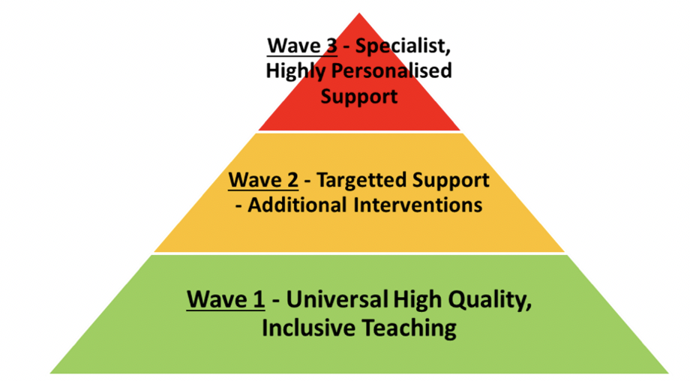
The "Waved" model for interventions.
8.2 Your child’s teacher/s is/are responsible and accountable for the progress and development of all the pupils in their class.
8.3 High-quality teaching (wave 1) is our first step in responding to your child’s needs. We will make sure that your child has access to a broad and balanced curriculum in every year they are at our school.
8.4 We will adapt how we teach to suit the way the pupil works best. There is no '1 size fits all’ approach to adapting the curriculum, we work on a case-by case basis to make sure the adaptations we make are meaningful to your child.
8.5 These adaptations may include:
- Explicit instruction of curriculum tasks and processes to give pupils access to it.
- Increased support, including grouping and 1-to-1 support from an adult.
- Adapting resources through scaffolded tasks.
- Adapting teaching and tasks, for example, giving longer processing times, pre-teaching of key vocabulary, reading instructions aloud, etc.
- Adapting and varying staffing
- Using recommended aids, such as laptops, coloured overlays, visual timetables, larger font, etc.
8.6 Where suggested or required by an Educational Health Care Plan, teaching assistants will work with pupils on a 1-to-1 basis, offering support whilst promoting independence.
8.7 We may also provide the following interventions:

Area of need | Condition | HOw we support these Pupils
Communication and interaction | Autism spectrum disorder (ASD) | Now and next  Visual timetable
Communication and interaction | Speech and language difficulties | Speech and language therapies  Concept cat intervention
Cognition and learning | Specific learning difficulties, including dyslexia, dyspraxia, dyscalculia | SNIP, IDL, Dyslexia Gold
Cognition and learning | Moderate learning difficulties
Cognition and learning | Severe learning difficulties
Cognition and learning | Profound and Multiple Learning Difficulties (PMLD): Physical Disability (PD)
Social, emotional and mental health | Mental Health and Well Being
Social, emotional and mental health | Social Need | Circle of friends
Social, emotional and mental health | Emotional Need | Pastoral needs
Social, emotional and mental health | Autism spectrum disorder (ASD) | Emotional education – ability to identify feelings  Regulation strategies
Social, emotional and mental health | Attention deficit hyperactivity disorder (ADHD)
Social, emotional and mental health | Attention deficit disorder (ADD)
Sensory and/or physical | Hearing impairments | Quiet workstation
Sensory and/or physical | Visual impairment | Enlarged text
Sensory and/or physical | Multisensory impairment | Sensory breaks
Sensory and/or physical | Physical Disability (PD)

Area of need | Condition | How we support these pupils
Communication and interaction | Autism spectrum disorder (ASD) | Visual timetables  Social stories
Communication and interaction | Speech and language difficulties | Speech and language therapy
Cognition and learning | Specific learning difficulties, including dyslexia, dyspraxia and dyscalculia | Writing slope
Cognition and learning | Moderate learning difficulties
Cognition and learning | Severe learning difficulties
Social, emotional and mental health | ADHD, ADD | Quiet workstation
Social, emotional and mental health | Adverse childhood experiences and/or mental health issues | Nurture groups
Sensory and/or physical | Hearing impairment
Sensory and/or physical | Visual impairment | Enlarged text, clear font
Sensory and/or physical | Multi-sensory impairment
Sensory and/or physical | Physical impairment

These interventions are part of our contribution to Worcestershire’s local offer.

9. How will the school evaluate whether the support in place is helping my child?
9.1 We will evaluate the effectiveness of provision for your child by:
- Reviewing their progress towards their goals each term
- Reviewing the impact of interventions after 6-8 weeks (depending on the intervention and need)
- Using pupil questionnaires
- Monitoring by the SENCO
- Using provision maps to measure progress
- Holding an annual review, if they have an education, health and care (EHC) plan.

10. How will the school resources be secured for my child?
10.1 It may be that your child’s needs mean we need to secure:
- Extra equipment or facilities
- More teaching assistant hours
- Further training for our staff
- External specialist expertise
10.2 If that’s the case, we will consult with external agencies to get recommendations on what will best help your child access their learning.
10.3 The school will cover up to £6,000 of any necessary costs. If funding is needed beyond this, we will seek it from our local authority.
10.4 Where your child’s needs are beyond what might be ordinarily available for mainstream education, we will ask you to work with us on an application for an Education & Health Care Plan, which brings expert advice, tailored targets and additional funding.

11. How will the school make sure my child is included in activities alongside pupils who don’t have SEN?
11.1 We are committed to the inclusion of all pupils within school life and take account of the equality duty, Equal Act 2010 and Section 100 of the Children and Families act as we endeavour to make reasonable adjustments and arrangements to allow full participation for pupils with SEND.
11.2 All of our extra-curricular activities and school visits are available to all our pupils, including our before and after-school clubs.
11.3 All pupils are encouraged to go on our school trips, including our residential trip(s) to Oakerwood.
11.4 All pupils are encouraged to take part in events such as, but not limited to, sports day/school plays/special workshops and swimming lessons off site.
11.5 No pupil is ever excluded from taking part in these activities because of their SEN or disability and we will make whatever reasonable adjustments are needed to make sure they can be included.

12. How does the school make sure the admissions process is fair for pupils with SEN or a disability?
12.1 The school’s admissions arrangements are managed by the Local Authority (Worcestershire County Council) maintains a fair admissions process in line with the Schools Admissions Code, the Children and Families Act and the Equality Act.
12.2 The school upholds the legal "First Priority" for EHCPs, namely that if a child has an Education, Health and Care Plan (EHCP) that names the specific primary school, the school must admit the child.
12.3 We will only contest being named in and Education Health Care Plan if we believe the placement is unsuitable for the child's age or ability, or that it would be incompatible with the efficient education of others or the efficient use of resources.
12.4 This decision will be made on a case-by-case basis, taking guidance from admissions and SEND services and with the intent that we will admit the child if possible.
12.5 For children who have SEN or a disability but do not have an EHCP, their applications are processed exactly the same as any other child, using the school's published oversubscription criteria (such as catchment area or siblings) which is managed in a consistent and transparent way by the County Council Admissions team.
12.6 To ensure equity during the application window itself, the school and the Local Authority which coordinates primary admissions must make reasonable adjustments and provide an accessible process. In Worcestershire:
  - applications are made through a centralized, accessible LA portal
  - information can be requested in alternative formats (e.g., large print, translated, or easy-read).
  - Families are encouraged to visit the school and speak directly with the SENCo (Special Educational Needs Coordinator) ahead of time to discuss transition arrangements, ensuring the application itself remains unbiased, and the school can prepare to give the pupil the best possible start.

13. How does the school support pupils with disabilities?
13.1 Where pupils have special educational needs and or disabilities, a graduated response will be implemented. The school will, other than where expert advice has agreed otherwise, make full use of classroom and school resources.
13.2 Reasonable adjustments and adaptions to curriculum and other provision will be made to ensure that pupils of all abilities are able to participate fully in school life.
13.3 Our vision promotes inclusion and flourishing for all. Our STRIVE values are designed to avoid discrimination and promote inclusion. All pupils are taught in class, in assemblies and across our SCARF (PSHE) curriculum to treat everyone equally and fairly, be curious about difference and to include and accept the variety of pupils they see around them.
13.4 Our behaviour policy is clear and consistent and discriminatory behaviour is noticed, tackled and dealt with rapidly.
13.5 Any pupils’ behaviour that discriminates against pupils with SEND and disabilities is traded seriously in line with the behaviour policy and logged as discriminatory behaviour.
13.5 The facilities you provide to help disabled pupils access your school, including the provision of auxiliary aids and services
13.6 Please also see our school’s accessibility plan on the school website:

14. How will the school support my child’s mental health, and emotional and social development?
14.1 All staff embrace personal, social and health development in school and work, in line with our distinct Christian vision, to promote pupils mental and emotional wellbeing so that they soar.
14.2 Sam Baylis is the named mental health champion, and Stephen Murphy is the schools Senior Mental Health Lead.
14.3 We have a waved pastoral support offer which offers guidance, support, listening and intervention to pupils struggling with their mental and emotional wellbeing.
14.2 We are a trauma-informed School. The SENDCo and deputy head have with Trauma-informed Schools (TiS) training and three members of staff, including the headteacher, are Thrive trained.
14.3 We provide pastoral interventions and encourage a therapeutic curriculum.
14.4 A comprehensive and well-taught PSHE curriculum is in place with a clear commitment to emotional and mental health and wellbeing.
14.4 We provide support for pupils to progress in their emotional and social development in the following ways:
- Pupils with SEN are encouraged to be part of the school council
- Pupils with SEN are also encouraged to be part of all aspects of school life including clubs, trips and extra curricular opportunities.
- Teachers promote opportunities for teamwork/building friendships wherever possible in the curriculum.
- provide extra pastoral support for listening to the views of pupils with SEN by our pastoral TAs.
- We run a nurture club for pupils at lunchtime for those who need extra support with social or emotional development
- We have a ‘zero tolerance’ approach to bullying. Please see our anti bullying policy.

15. What support will be available for my child as they transition between classes or settings, or in preparing for adulthood?
15.1 Between years
To help pupils with SEN be prepared for a new school year we:
- In our small setting all staff take assemblies and are on playtime duties throughout the week which gives children the opportunity to recognise them initially.
- In addition, children are regularly taught by teachers in their next class which aids transition immeasurably.
- We hold a transition day across the school, so children and adults get to know each other and experience the environment.
- Both the current teacher and the next year’s teacher attend a final meeting of the year when the pupil’s SEND is discussed, and a full inclusion handover takes place
15.2 Between schools
When your child is moving on from our school, we will ask you and your child what information you want us to share with the new setting. This does not affect statutory information sharing, but we will work with you to send the right information so the new school can ensure a flying start for your child.
15.3 Between phases (to other primary schools)
15.31 The SENCO of the primary school meets with our SENCO to discuss the needs of the incoming pupils near the end of the summer term.
15.32 We arrange meetings with the parents/carers of incoming pupils to discuss how we can best welcome their child into our community.
15.33 Pupils are given a tour of the school and a taster day to help them acclimatise and adjust
15.34 We meet with parents to explore adaptions and reasonable adjustments which may make the transition smoother.
15.35 We set up new pupils with a buddy from the year above to help them get settled in and make friends.
15.4 Between phases (to secondary schools)
15.41 The SENCO of the secondary school will come into our school for a meeting with our year 6 teacher and deputy head Mrs Charles. They will discuss the needs of all the children who are receiving SEN support and/or with EHCPs. We encourage families to take part in all the transition opportunities offered by the high school. Additional transition days will be made available for pupils with SEND.
15.42 Where parents are seeking special educational route for high school. The SENDCo can support the search and advise about the process but not make recommendations.

16. What support is in place for looked-after and previously looked-after children with SEN?
16.1 Children who are looked-after or previously looked-after are vulnerable children and their progress will be monitored by the appropriate staff. Their SEND needs will be supported in the same way as any other child who has SEN. However, looked-after pupils will also have a personal education plan (PEP). We will make sure that the PEP and any SEN support plans or EHC plans are consistent and complement one another.
16.2 The Designated Teacher for LAC and Post-LAC is Mr Murphy.

17. What should I do if I have a complaint about my child’s SEN support?
17.1 Parents can request a copy of the complaint procedure from the school office
17.2 To see a full explanation of suitable avenues for complaint, see pages 246 and 247 of the SEND Code of Practice.
17.3 If you feel that our school has discriminated against your child because of their SEN, you have the right to make a discrimination claim to the first-tier SEND tribunal. To find out how to make such a claim, you should visit: https://www.gov.uk/complain-about-school/disability-discrimination
17.4 You can make a claim about alleged discrimination regarding:
- Admission
- Exclusion
- Provision of education and associated services
- Making reasonable adjustments, including the provision of auxiliary aids and services
17.5 Before going to a SEND tribunal, you can go through processes called disagreement resolution or mediation, where you try to resolve your disagreement before it reaches the tribunal. For SEND mediation in Worcestershire please visit:
https://www.worcestershire.gov.uk/council-services/schools-education-and-learning/send-local-offer/im-not-happy-decision-send/im-not-happy-my-childs-ehcp-send/mediation-send

18. What support is available for me and my family?
18.1 If you have questions about SEN, or are struggling to cope, please get in touch to let us know. We want to support you, your child and your family.
18.2 To see what support is available to you locally, have a look at https://www.worcestershire.gov.uk/council-services/schools-education-and-learning/send-local-offer/all-age-disability-0-25-years-service-send/send-services your local authority’s [insert the name or names of local authorities in your catchment area] local offer.
18.3 Our local special educational needs and disabilities information, advice and support (SENDIAS) services are available here https://www.worcestershire.gov.uk/sendiass
18.3 Local charities that offer information and support to families of children with SEND can be found here:
https://www.worcestershire.gov.uk/council-services/schools-education-and-learning/send-local-offer/useful-websites-and-organisations-send
18.4 National charities that offer information and support to families of children with SEN are:
- IPSEA
- SEND family support
- NSPCC
- Family Action
- Special Needs Jungle

19. Glossary
Access arrangements – special arrangements to allow pupils with SEN to access assessments or exams
Annual review – an annual meeting to review the provision in a pupil’s EHC plan
Area of need – the 4 areas of need describe different types of needs a pupil with SEN can have. The 4 areas are communication and interaction; cognition and learning; physical and/or sensory; and social, emotional and mental health needs
CAMHS – child and adolescent mental health services
Differentiation – when teachers adapt how they teach in response to a pupil’s needs
EHC needs assessment – the needs assessment is the first step on the way to securing an EHC plan. The local authority will do an assessment to decide whether a child needs an EHC plan
EHC plan – an education, health and care (EHC) plan is a legally-binding document that sets out a child’s needs and the provision that will be put in place to meet their needs
First-tier tribunal / SEND tribunal – a court where you can appeal against the local authority’s decisions about EHC needs assessments or plans and against discrimination by a school or local authority due to SEN
Graduated approach – an approach to providing SEN support in which the school provides support in successive cycles of assessing the pupil’s needs, planning the provision, implementing the plan, and reviewing the impact of the action on the pupil
Intervention – a short-term, targeted approach to teaching a pupil with a specific outcome in mind
Local offer – information provided by the local authority that explains what services and support are on offer for pupils with SEN in the local area
Outcome – target for improvement for pupils with SEN. These targets don't necessarily have to be related to academic attainment
Reasonable adjustments – changes that the school must make to remove or reduce any disadvantages caused by a child’s disability
SENCO – the special educational needs co-ordinator
SEN – special educational needs
SEND – special educational needs and disabilities
SEND Code of Practice – the statutory guidance that schools must follow to support children with SEND
SEN information report – a report that schools must publish on their website, that explains how the school supports pupils with SEN
SEN support – special educational provision that meets the needs of pupils with SEN
Transition – when a pupil moves between years, phases, schools or institutions or life stages

Vicky Whitehurst
Stephen Murphy
September 2026

